**Mutation Testing Lab**

**Nour bachraoui**

**Nour bennour**

**Nour khellia**

**Iheb Jendoubi**

For the complex methods where we couldn’t kill some mutant here’s a detailed investigation :

**Method :addRiders:**

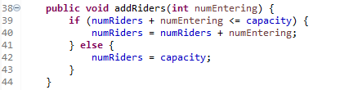

CFG :

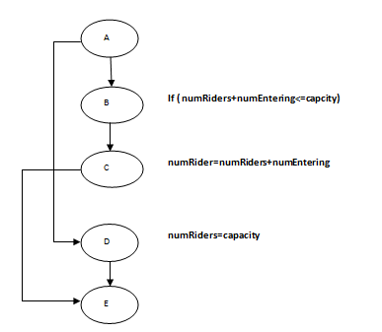

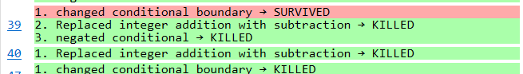

6 mutants was created for this method !

I could not kill the mutant “Changed Conditional boundary🡪 survived”

Investigation : the mutantions could be :

numRiders+numEntering<Capacity: I COULD not killed this mutant because if this is the mutation , then it s an equivalent mutant 🡺 (0+20 <20): False then numRiders=20 Or( 0+20<=20):True then numRider=0+20=20

numRiders+numEntering>Capacity: I tried many assertive such as

lift.addDrivers(25);

assertEquals(20,lift.getNumRider());//But it doesn t kill the mutant

numRiders+numEntering>=Capacity: // Same as previous mutant

**CallMethod():**

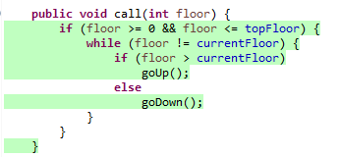

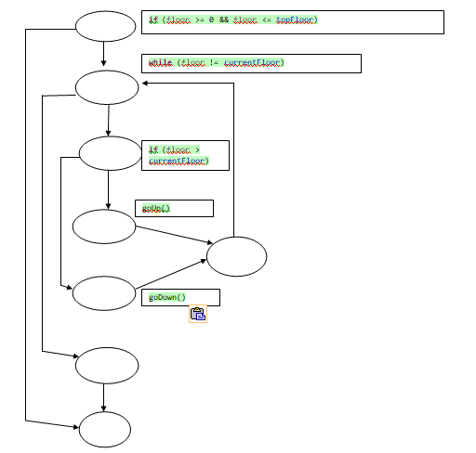

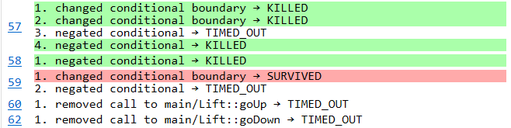

Generated Mutant for this method :

Killed 4/1Survived /4 timed out

Why the mutant one survived ! changed conditional boundary :

Original : if (floor >currentFloor)

Mutant 1 : (floor<currentFloor )

Remark : we didn’t consider the other possibilities because to enter this if we must have floor !=current floor

Actually with mutant 1 once the if condition is True is will go up() forever it s an infinite loop

I couldn’t kill mutant 1 !

**For the other methods here’s a screenshot :**

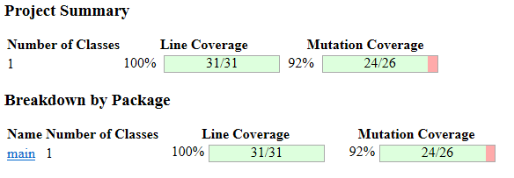

With my test cases I achieved 100% branch coverage , but killed 24 mutant out 26

* I can conclude that the quality of my test is good

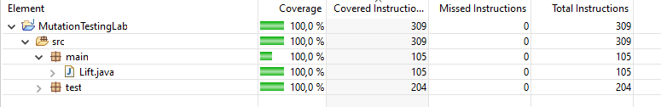

**Here a screen shot of the test cases :**

